 

Q1:

Software Requirements Specification

for

Pet Medical Appointment System

Version 1.0 approved

Prepared by

Tran Van A - SExxxxxx

FU – Ho Chi Minh

26-03-2024

Q2:

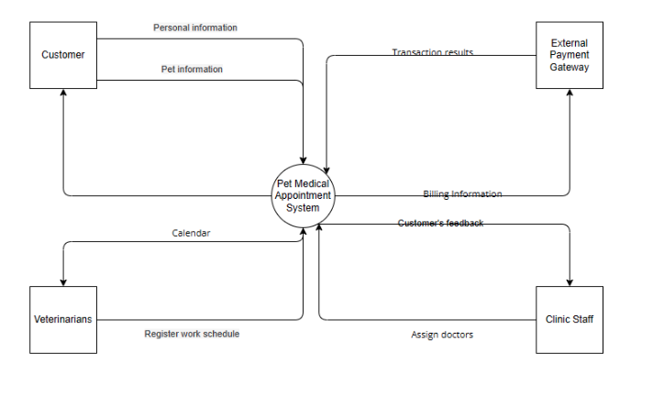

Q3:

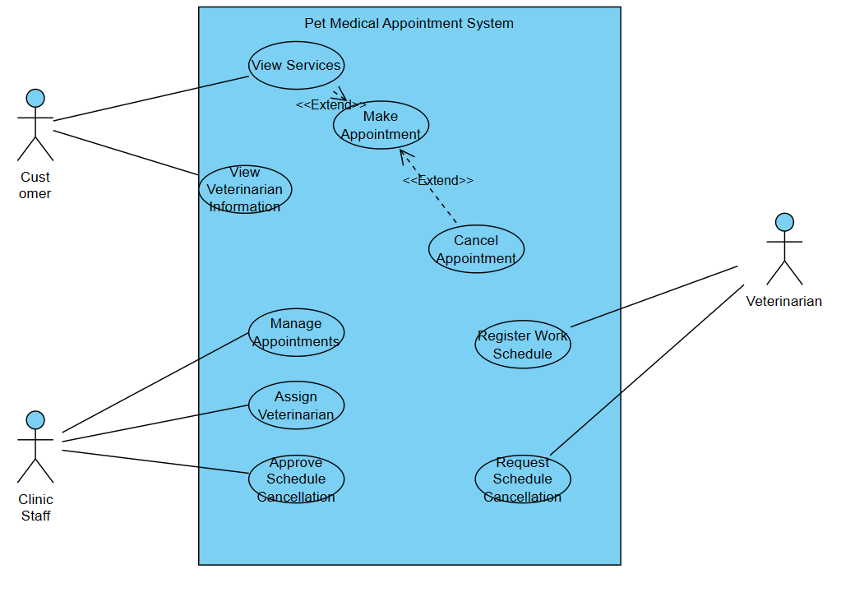<Student must replace this line, answer Q3 by drawing 1 use case diagram that reflect this exam paper and copy and then paste the image of that use case diagram here>

< Student must replace this line, **briefly describe** the actors of the diagram by fill the content to below table>

|  |  |  |
| --- | --- | --- |
| **#** | **Actor** | **Description** |
| 01 | Customer | A person who schedules appointments for their pets. |
| 02 | Clinic Staff | Administrative personnel responsible for managing appointments. |
| 03 | Veterinarian | Medical professionals providing services at the clinic. |

< Student must replace this line, **briefly describe** the use cases of the diagram by fill the content to below table>

|  |  |  |  |
| --- | --- | --- | --- |
| **#** | **Use Case** | **Actors** | **Description** |
| UC-01 | View Services | Customer | Allows customers to view medical examination and treatment services. |
| UC-02 | View Veterinarian Information | Customer | Allows customers to view biographical information of veterinarians. |
| UC-03 | Make Appointment | Customer | Enables customers to schedule appointments for their pets. |
| UC-04 | Cancel Appointment | Customer | Allows customers to cancel appointments within the specified time frame. |
| UC-05 | Manage Appointments | Clinic Staff | Allows clinic staff to view, change, or cancel customer appointments. |
| UC-06 | Assign Veterinarian | Clinic Staff | Enables clinic staff to assign a veterinarian if not specified by the customer. |
| UC-07 | Approve Schedule Cancellation | Clinic Staff | Enables clinic manager to approve or deny requests for schedule cancellation. |
| UC-08 | Register Work Schedule | Veterinarian | Allows veterinarians to register their work schedule. |
| UC-09 | Request Schedule Cancellation | Veterinarian | Allows veterinarians to request cancellation of their work schedule. |

Q4:

|  |  |  |
| --- | --- | --- |
| ID | Rule Definition | Use cases |
| BR-01 | Discount for Multiple Pets:  When a customer schedules appointments for two or more pets, they receive a 15% discount on medical examination services. | UC-01, UC-02 |
| BR-02 | Appointment Cancellation Policy:  Customers can cancel appointments 24 hours before the scheduled examination time. If canceled within the stipulated time frame, the system transfers the paid money back to the customer. | UC-04 |
| BR-03 | Approval of Veterinarian Work Schedule:  Veterinarians can register for a work schedule, but it needs approval from the clinic manager.  Only veterinary work schedules approved by the manager can be booked by customers. | UC-08 |
| BR-04 | Authentication for Customer Access:  Customers must log in through an account registered with the system or using a Google account before scheduling an appointment. | UC-03 |
| BR-05 | Encryption of Sensitive Data:  All network transactions involving financial information or personally identifiable information require 256-bit encryption. |  |

**Q5:**

a. Security

Data encryption: All network transactions involving financial or personally identifiable information require 256-bit encryption. Testers can verify the implementation of encryption protocols by examining network traffic and ensuring that sensitive data is encrypted using the specified encryption algorithm.

Authentication: The system must authenticate users before allowing access to sensitive functions such as appointment scheduling and payment processing. Testers may attempt to access these functions without the appropriate credentials to verify that unauthorized access is denied.

b. Performance

Response time: The system will respond to user interactions within 2 seconds for critical functions such as appointment scheduling and payment processing. Testers can measure the time it takes for the system to respond to a user's action and compare it with a specified threshold.

Scalability: The system must handle a minimum of 100 concurrent users without sacrificing performance. Testers can simulate concurrent user access and monitor system performance metrics to ensure scalability requirements are met.